1. **Query to display Employee Name, Job, Hire Date, Employee Number; for each employee with the Employee Number appearing first.**

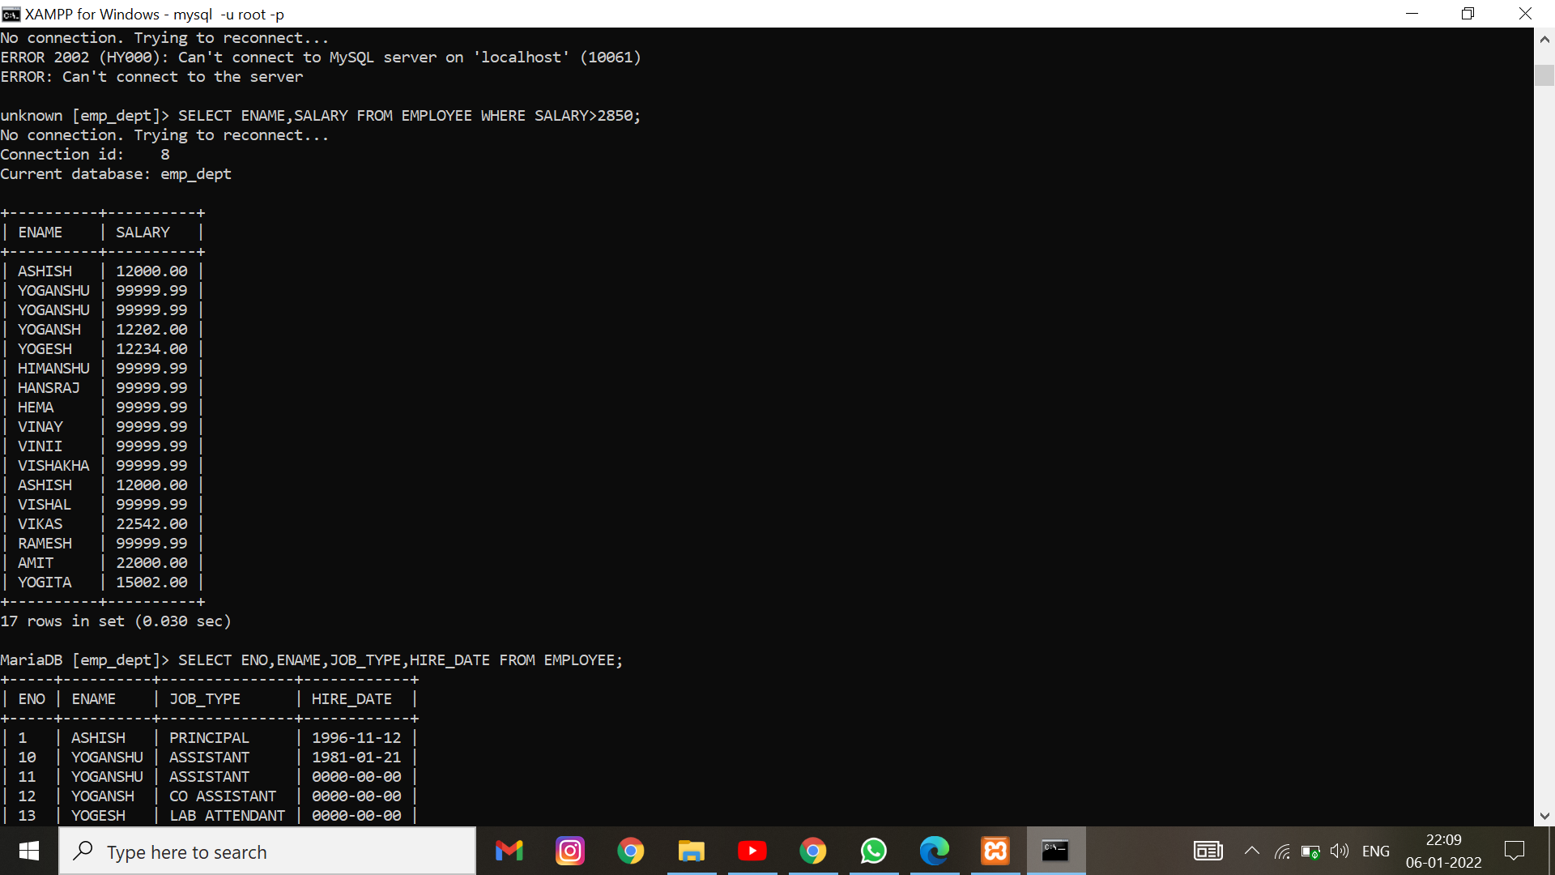

1. **. Query to display unique Jobs from the Employee Table**

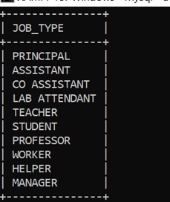

1. **Query to display the Employee Name concatenated by a Job separated by a comma.**

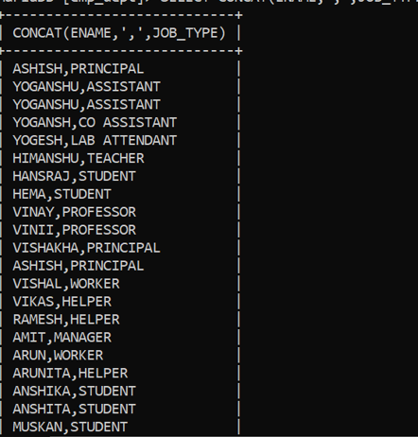

1. **Query to display all the data from the Employee Table. Separate each Column by a comma and name the said column as THE_OUTPUT.**

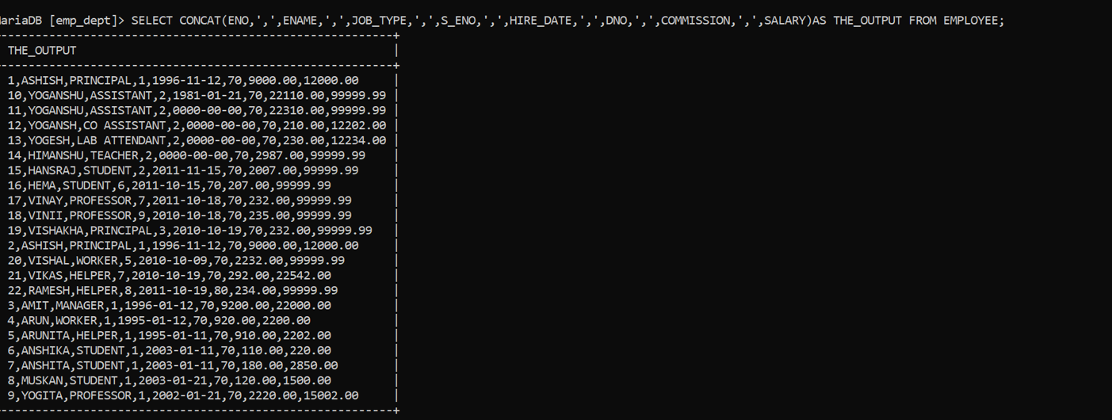

1. **Query to display the Employee Name and Salary of all the employees earning more than $2850.**

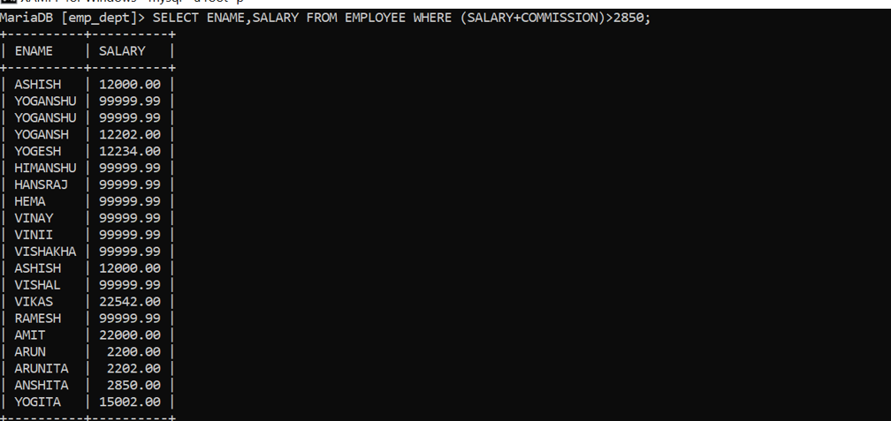

1. **Query to display Employee Name and Salary for all employees whose salary is not in the range of $1500 and $2850.**

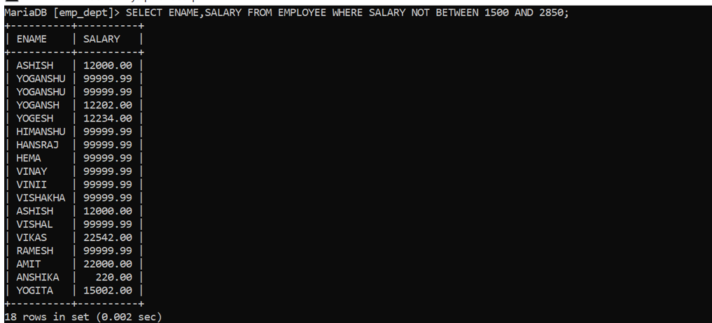

1. Query to display Employee Name and Department Number for the Employee No= 79.

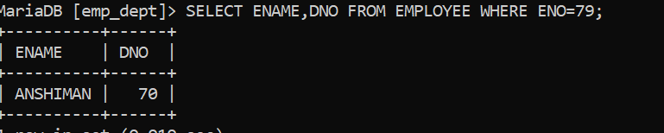

1. **Query to display Employee Name and Department No. of all the employees in Dept 10 and Dept 30 in the alphabetical order by name.**

